
LEEDS COMMUNITY HEALTHCARE NHS TRUST

JOB DESCRIPTION

Job Details

Job Title: Senior Nurse

Banding: Clinical Band 6

Specialty/Department: Adult Business Unit

Service Description:

The Community Neighbourhood Nursing Night Service operates over a 24 hour period, providing holistic high quality domiciliary nursing care to patients registered with a Leeds General Practitioner. The service delivers care overnight as part of the Health and Social Care Team within each Neighbourhood. The service operates from 21.00 to 07.30.

The service aims to reduce hospitalisation and promote discharges through robust multi-disciplinary working with internal services, external services / organisations and the third sector. The service supports palliative care patients to die in their preferred place of care.

The key working relationships include the Neighbourhood Teams Clinical Leads, Joint Care Management, external agency providers, Marie Curie, Commissioners and Administrative Staff.

Job Purpose

The post holder will be responsible for their own caseload within their speciality area as an autonomous practitioner. In doing so, they will assess, plan, deliver and evaluate patient centred care to a specialist level ensuring that they practice within their sphere of competence and knowledge.

The post holder will work to professional and regulatory body codes, standards and guidance at all times ensuring that their practice is grounded in evidence based theoretical and practical knowledge.

Key responsibilities

- Clinical

  - Holistically assess/reassess and continuously review allocated patients to ensure their nursing needs are being met, collaborating with the multidisciplinary integrated team to ensure all identified needs are addressed.
  - Act as Case Manager and Named Clinician for appropriate patients, i.e. those with complex needs requiring senior nurse assessment and review, visiting them with appropriate frequency.
  - Act as Case Manager for those patients allocated to named clinicians within the Caseload Cluster, providing oversight and support to the named clinicians and the patient as required and requested to ensure safe, effective, quality care is delivered to all patients in the Caseload Cluster.
  - Electronically plan patient visits and maintain own electronic diary management for patient care to make every contact count.
  - Ensure patients requiring more in depth case management from a multidisciplinary perspective are referred into the Case Management Meeting process within the Neighbourhood Team (NT). Ensure team representation at Case Management meetings within the NT
  - Maintain and deliver compassionate patient focused care in accordance with LCH guidelines, policies, values and behaviours.
  - Ensure that documentation standards, whether written or electronic, are maintained in accordance with NMC and Trust guidelines.
  - Comply with the organisation’s Infection Prevention and Control requirements, including “bare below the elbows” dress code when delivering direct care to patients.

  - Communicate with the patient and/or their family/carer to ensure they are involved in agreeing goals with regard to their identified needs and have access to appropriate information and knowledge, which may be complex, in order to inform decision making.
  - Promote evidence based practice and use a health coaching approach wherever possible with patients so that they are empowered and supported to manage their own care.

  - Balance clinical risk and clinical decision making against context, ensuring patients receive safe, effective and timely care.

  - Participate in the triage clinician role for the Neighbourhood Team, effectively handling referrals into the team, demonstrating sound clinical decision making and use of SystmOne and the Electronic Patient Record (EPR) systems and processes that provides clear evidence of effective management.

  - Participate in the Hub rota to manage Out of Hours workload, effectively managing and triaging planned and unplanned work according to staffing capacity, safety and competence.

  - Demonstrate a high level of clinical competence and a high level of specialist knowledge with regard to care delivery, thereby demonstrating clinical credibility and being a credible clinical role model within the team.

  - Manage the safe transfer of care between care providers and make appropriate referrals to other care providers outside of the integrated team.

  - Demonstrate good insight, knowledge of and adherence to Trust Safeguarding policies and procedures to safeguard the health and wellbeing of children and vulnerable adults

  - Recognise ethical and legal issues which have implication for nursing practice and take appropriate action in line with NMC guidelines

  - Maintain a safe working environment, ensuring the safe use and efficient management of equipment and supplies

1.15 Work in accordance to the Nursing and Midwifery Council (NMC) code of conduct and fulfil the requirements to maintain and revalidate registration.

- Leadership

2.1 Prioritises their own workload, and that of their wider team. Has a sound knowledge of the skills and competence of all team members in order to delegate appropriately to ensure safe delivery of service
2.2 Ensure all patients within the Caseload Cluster are holistically assessed by the most senior appropriate clinician within the team to identify nursing needs, collaborating with the multidisciplinary integrated team and referring to and liaising with other agencies as appropriate.

2.3 Work alongside the Community Matron to effectively manage the Caseload Cluster on a daily basis. This includes ensuring safe prebooking of visits and allocation has taken place and that patient care is discussed and reviewed at daily handover.

2.4 Continuously reviews their caseload alongside the Community Matron, ensuring patients are allocated the appropriate caseload manager and named clinician and visiting frequency is appropriate for patient need.

2.5 Uses clinical leadership skills and initiative to creatively solve problems.

2.6 Acts as a role model to ensure professional service and image is maintained at all times.

2.7 Provides and demonstrates leadership underpinned by the Trust’s vision, values and behaviours.

2.8 Contribute to the clinical line management of staff within the team, undertaking meaningful annual appraisal and regular one to ones, which are recorded, identifying areas for development that are demonstrably acted upon.

2.9 Escalate any performance/conduct issues that are giving rise for concern and contribute to the management of those issues as required.

2.10 Takes responsibility for their own and others’ health and safety in the working environment.

- Learning and Development

  - Undertakes any training required to develop or maintain their expertise within the service area

  - Ensure all new starters, inclusive of temporary staff, have a high quality local induction to the clinical area and ensure participation in preceptorship and mentorship programmes within the team.

  - Ensure all team members are up to date with their statutory and mandatory training

  - Promote a learning and development culture to improve staff skills, knowledge and competence, ensuring skills and knowledge are shared across the team to develop the confidence and competence of junior staff.

  - Participates in clinical supervision as per Trust policy requirements and ensures the team are doing so. Ensures that clinical supervision activity is formally reported.

  - Contribute to the assessment of student nurses pre-registration, working towards sign off mentorship status in line with NT requirements.

  - Support and facilitate re-validation for registered nursing staff within the team.

- Partnership and Team Working

  - Establishes and maintains communication with multidisciplinary teams to collaboratively plan and implement programmes of care. Actively works towards developing and maintaining effective working relationships both within and outside the Trust.

  - Participates in service design/development discussions/projects, contributing expertise and clinical knowledge to the process.

  - Acts as a credible source of information for other agencies/professionals.

- Innovation and Quality

  - Implements and monitors agreed standards of care, reporting to neighbourhood Clinical Quality Lead (NCQL) when standards are not met.

5.2 Ensures incidents, clinical and non-clinical, are reported and investigated in a timely manner and any learning shared with the team and wider NT as appropriate.

  - Undertakes reviews and Root Cause Investigations within agreed timescales, escalating to Operational and Clinical Quality Leads where these are at risk of late completion.

  - Implements policies and ensures team members are aware of them.
  - Actively works to continually improve the quality and safety of the service.
  - Contributes to and undertakes clinical audit as required.
Health and Safety

Responsibilities of ALL staff in relation to Health and Safety:-
- Take reasonable care of your own health and safety
- Take reasonable care not to put other people - fellow employees and members of the public - at risk by what you do or don't do in the course of your work
- Co-operate with Trust, making sure you understand and follow the health and safety policies and procedures
- Attend all required training on Health and Safety related policies and procedure.
- Do not interfere with or misuse anything that has been provided for your health, safety or welfare
- Report and record any injuries, strains or illnesses suffered as a result of doing your job
- Inform your manager if something happens that might affect your ability to work safely such as suffering an injury or a new medical condition.

Additional for those with management responsibilities:
- Identify through documented risk assessment any risks that exists within the department or during the delivery of the service
- Investigate and manage incidents and near misses, ensuring actions are taken to prevent recurrence
- Support the Risk and Safety Team in ensuring suitable and sufficient up to date Health and Safety information and guidance is available to all staff at all levels and disciplines across the organisation.

In addition to these functions the post holder is expected to:
- In agreement with their line manager carries out such other duties as may be reasonably expected in accordance with the grade of the post.
Our Vision, Values, and Behaviours

Our Vision
- We provide the best possible care to every community we serve

Our Values
- We are open and honest and do what we say we will
- We treat everyone as an individual
- We are continuously listening, learning, and improving

Our Behaviours
- As a Trust, we have identified seven key behaviours needed by every member of staff across the organisation to ensure we carry out our vision and live our values, known as How We Work.
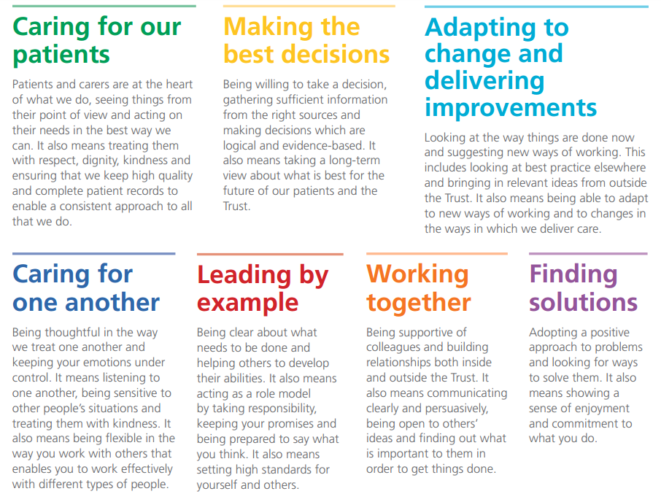

To make sure the Trust’s vision is realised, and our staff are successful in their roles, all of our people need to display each of our seven behaviours at the individual level.

Effort Factor Information
PHYSICAL EFFORT  What physical skills needed in the role require, speed, accuracy, dexterity and or manipulation of objects (includes both clinical and non-clinical posts)? Please provide specific examples.  Is the post holder required to lift equipment? If yes, please specify type of equipment, weight (approx kilos) and frequency of the requirement. Please provide specific examples. | Frequent sitting or standing in a restricted position/ moderate to intense effort for several short periods.  E.g. Kneels or crouches to deliver treatment, manoeuvres patients and equipment
MENTAL EFFORT  Describe the amount of concentration required within the day-to-day job. What is it the employee will have to concentrate on? Please give examples of how often and for how long this concentration occurs. Please provide specific examples of when mental effort is required.  Is the post holder required to drive a vehicle? If so please specify duration and frequency. | Frequent concentration on patient treatment, tests, care plans, works to schedule visits, calculating doses
EMOTIONAL EFFORT  Does any part of the job require any emotional effort? What elements of the role expose the employee to emotional effort?  How often does this happen? Please provide specific examples. E.g. exposure to child protection issues | Frequent distressing or occasional highly distressing or emotional circumstances e.g. deals with distressed patients or relatives, imparting distressing news in relation to clinical status, managing staff; dealing with safeguarding concerns
WORKING CONDITIONS  Is the post holder required to work in extreme heat or cold, with smells, noise or fumes which are unavoidable, even with the strictest health and safety controls? Does the post holder work with clients or patients who express aggressive verbal or non-verbal behaviour or similar. Please describe the requirement and the frequency with which this may occur. | Frequent unpleasant conditions or occasional highly unpleasant e.g. smell, dirt; weather conditions; challenging behaviour; aggression; body fluids

TERMS AND CONDITIONS OF SERVICE

Band: | 6
Hours: | 30 hours per week
Contract: | Permanent
Salary: | £37,338 - £44,962 per annum
 | New staff will normally be appointed to the minimum of the pay band. Staff transferring from one post to another in the same pay band within the NHS will enter the band at the same point that they were previously on. Staff promoted within the NHS will enter the new pay band at the minimum or the first point of the new pay band that gives them an increase in salary. Any previous NHS service will be subject to confirmation by the Payroll Department.
Annual Leave: | The annual leave year runs from 1 April to 31 March following.  The full entitlement being 27 days for a full year and pro rata  for an incomplete year's service. An additional 2 days will be  awarded after 5 years service plus a further 4 days after 10  years service. This is in addition to 8 public and statutory days  holiday.
NHS Pension: | The post is pensionable unless you opt out of the scheme or  are ineligible to join and your remuneration will be subject to  deduction of contributions in accordance with the National  Health Service Pension Scheme. In the event of you not  wishing to join the scheme you should complete form SD502  on your commencement date.
Medical: | The appointment maybe subject to you completing a declaration of health form, which may lead to a full medical examination upon request.
Notice: | Giving notice – you are required to give the Trust 8  weeks written notice of termination of your employment.  Receiving notice – with the exception of ‘Summary Dismissal’ you will be entitled to receive notice of 8 weeks or your statutory notice entitlement whichever is the greater.  Statutory entitlement is:  For staff with more than 4 weeks continuous service, entitlement to notice is 1 week for each year of completed service up to a maximum of 12 weeks.
PROFESSIONAL REGISTRATION

Where it is a requirement as part of this job role to be registered with a Professional Body, you are required to maintain and update your registration in line with the Trust’s Professional Registration Policy. You are required to provide proof of your registration status on your appointment, at renewal of registration or at any other time as requested by the Trust. It is also a requirement for you to comply with any Codes of Professional Conduct and to update/satisfy any Continuous Professional Development conditions.

It would also be a requirement for you to comply with any Codes of Professional Conduct and to update/satisfy any Continuous Professional Development conditions.

REHABILITATION OF OFFENDERS ACT 1974

Because of the nature of the work for which you are applying, this post is exempt from the provisions of Section 4(2) of the Rehabilitation of Offenders Act 1974. Applicants are, therefore, not entitled to withhold information about convictions which for other purposes are 'spent' under the provisions of the Act, and, in the event of employment any failure to disclose such convictions could result in dismissal or disciplinary action by the Trust. Any information given will be completely confidential and will be considered only in relation to an application for positions to which the Order applies.

DBS CHECK (Formerly CRB)

This post is subject to the Rehabilitation of Offenders Act (Exceptions Order) 1975 and as such it will be necessary for a submission for Disclosure to be made to the Disclosure & Barring Service to check for any previous criminal convictions.

The Trust is compliant with the Disclosure & Barring Service ‘Code of Practice’, a copy of which is available on request.

The Trust welcomes applications from a wide range of candidates including those with a criminal record. It undertakes not to discriminate unfairly against any subject of a Disclosure on the basis of a conviction or other information revealed. A full Trust policy on the Recruitment of Ex-offenders is available on request.

SECTION 11 COMPLIANCE

Safeguarding Children and Vulnerable Adults
All employees are required to act in such a way that at all times safeguards the health and well being of children and vulnerable adults. Familiarisation with and the adherence to the Trust’s Safeguarding policies is an essential requirement of all employees as is participation in related mandatory/statutory training.

ORGANISATIONAL AND STATUTORY REQUIREMENTS

All employees should understand that it is their personal responsibility to comply with all organisational and statutory requirements, e.g. Health and Safety; Equal Treatment and Diversity; Confidentiality; Infection Prevention and Control.
MENTAL CAPACITY ACT (MCA 2005 CODE OF PRACTICE)

This Act applies to all persons over the age of 16 who are judged to lack capacity to consent or withhold consent to acts which are considered by health and social care professionals to be in the best interests of their welfare and health.

The Mental Capacity Act 2005 imposes a legal requirement on health and social care professionals to ‘have regard to’ relevant guidance within the Code of Practice when acting or making decisions on behalf of someone who lacks capacity to make the decision for themselves. Furthermore, they should be able to explain how they had regard to the Code when acting or making decisions.

Detailed guidance is available in the Mental Capacity Act 2005 Code of Practice http://www.dca.gov.uk/legal-policy/mental-capacity/mca-cp.pdf

NOTE

This job description does form a part of the contract of employment and indicates how that contract should be performed. The job description will be subject to amendment in the light of experience and in consultation with the postholder.

JOB SHARE

This post is suitable for job sharing and when filled on this basis will attract all normal terms and conditions of service outlined above, but on a pro rata basis if appropriate.

SMOKING

The Trust operates a no smoking policy and is smoke free.

LEEDS COMMUNITY HEALTHCARE NHS TRUST
PERSON SPECIFICATION - Senior Nurse
Attributes | Essential | Desirable | How identified?
QUALIFICATIONS | Professional degree or diploma in relevant field  Post Graduate qualification in specialist field or equivalent experience  Must be willing to participate in any relevant training identified to develop skills required to carry out duties  Maintains a portfolio of CPD in line with regulatory body standards  Current NMC registration | Supporting Learning in Practice (SLIP) or equivalent  Leadership and management training – ILM 3 or equivalent | Application
EXPERIENCE | Significant post registration experience  Experience in supervising and delegating to other members of staff  Working in/alongside/involvement with adult nursing community teams  Experience of working in a multidisciplinary team |  | Application
KNOWLEDGE & UNDERSTANDING | Detailed theoretical and clinical knowledge  Knowledge of relevant current issues in health and social care  Is aware of confidentiality in relation to role  Demonstrates understanding of responsibility and accountability  Demonstrates awareness of limits to knowledge base  Evidence of understanding of team work  Shows awareness of local and national initiatives  Ability to supervise a team on a daily basis | Understanding of clinical governance and quality measures in practice | Application  Interview
PRACTICAL & INTELLECTUAL SKILLS | Specialist assessment, planning and evaluation skills  Proficiently performs tasks relevant to clinical role  Complex analytical and creative problem solving skills in unpredictable situations  Manage workload and delegate tasks  Effective verbal, non-verbal and written communication skills including communicating complex or potentially distressing information to patients / carers and managing conflict when appropriate  Risk assessment skills  Able to give clear and effective feedback  Able to research, understand and evaluate evidence to contribute to practice development  Has competent IT skills | Demonstrates ability to teach & assess outcome for patients/carers & students | Application  Interview
TRAINING | Must be willing to participate in any relevant training identified to develop skills required to carry out duties |  | Application Form  Interview  References
ATTITUDE & BEHAVIOUR | Displays care, compassion and responsiveness to other peoples’ feelings and needs  Able to work as part of a team and willing to help and assist wherever possible and appropriate  Able to develop, establish and maintain positive relationships with others both internal and external to the organisation  Able to work under pressure, dealing with peaks and troughs in workload  Positive and flexible attitude to dealing with change  Ability and willingness to adopt a flexible approach  Willing to explore new ways of doing things  Able to respond to the changing needs of the patient in an appropriate and timely manner  Highly motivated and reliable  Has a strong degree of personal integrity; able to adhere to standards of conduct based on a sense of right and wrong and be dependable and reliable  Demonstrates values consistent with those of the Trust |  | Application Form  Interview  References
Car owner/driver or suitable alternative transport to enable you to undertake the job (it is unlikely that public transport will meet this requirement). Reasonable adjustments can be considered in accordance to the Equality Act.

