

**LEEDS COMMUNITY HEALTHCARE NHS TRUST**

**JOB DESCRIPTION**

|  |
| --- |
| Job Details  **Job Title:** Community Staff Nurse  **Banding:**  Band 5  **Specialty/Department:** Adult Business Unit  **Reports to:**  **Accountable for:** |

|  |
| --- |
| **Service Description:**  The District Nursing Service operates over a 24 hour period, providing holistic high quality domiciliary nursing care to patients registered with a Leeds General Practitioner. The service delivers care overnight as part of the Health and Social Care Team within each Neighbourhood. The service operates from 21.00 to 07.30.  The service aims to reduce hospitalisation and promote discharges through robust multi-disciplinary working with internal services, external services / organisations and the third sector. The service supports palliative care patients to die in their preferred place of care.  The key working relationships include the District Nurse, Community Staff Nurse, Community Nursing Assistant, Clinical Leads, Joint Care Management, external agency providers, Marie Curie, District Nursing Operational Leads, Commissioners and Administrative Staff. |

**Job Purpose**

The post holder will be responsible for their designated workload within their speciality area without supervision and will have access to support from a senior clinician

The post holder will be responsible for the assessment of patients care needs and the development, implementation and evaluation of programmes of patient care working within an integrated Neighbourhood Team

1. **Clinical**
   1. Act as a named clinician for a group of patients and ensure that they are effectively case managed by having regular discussions and oversight from the case manager within the Caseload Cluster and conducting regular joint caseload reviews
   2. Holistically assess and review the needs of patients in collaboration with the multi-disciplinary team members to ensure all identified needs are addressed
   3. Electronically plan patient visits and maintain own electronic diary management for patient care to make every contact count
   4. Actively participate in daily handover meetings and safety huddles to plan and evaluate patient care
   5. Refer and present patient cases requiring a multi-disciplinary approach to the monthly case management meeting and work with members of the team to plan and deliver future care
   6. Manage the safe transfer of care between care providers and make appropriate referrals to other care providers outside of the integrated team
   7. Work in accordance with the Nursing and Midwifery Council (NMC) Code of Conduct
   8. Maintain documentation standards, whether written or electronic in accordance with NMC and LCH guidelines
   9. Use a health coaching approach wherever possible to empower patients and carers and promote self-care
   10. Communicate with patients and/or their family/carer to ensure they are involved in agreeing goals with regard to their identified needs and have access to appropriate information to make informed decisions
   11. Participate in teaching, supervising and assessing student nurses and other members of staff, working towards sign off mentorship status in line with NT requirements
   12. Balance clinical risk and clinical decision making against context, ensuring patients receive safe, effective and timely care
   13. Maintain and deliver compassionate patient focused care in accordance with LCH guidelines, policies, values and behaviours
   14. Support the senior clinicians to triage referrals and unplanned work, delegating to appropriate individuals within their scope of practice
   15. Demonstrate clinical competence with regards to care delivery and treatment using defined competencies in areas including wound care, palliative care and management of long term conditions
   16. Comply with the organisation’s Infection Prevention and Control requirements, including “bare below the elbows” dress code for staff with a direct care role
   17. Demonstrate good insight, knowledge and adherence to Trust Safeguarding policies and procedures to safeguard the health and wellbeing of vulnerable adults and children
2. **Self-Leadership**
   1. Prioritise own workload, delegating to others where appropriate
   2. Demonstrate responsibility for health and safety in the working environment utilising risk assessment tools and escalating where necessary
   3. Comply with the policies and procedures of the Trust
   4. Ensure that a professional service and image is maintained at all times and act as a role model for others
   5. Ensure own actions support the equality, diversity, rights and responsibilities of individuals

**3. Learning and Development**

3.1 Undertake any training required to develop or maintain their expertise within the service area

3.2 Reflect on own practice and access regular clinical supervision

3.3 Prepare and participate in an annual appraisal and regular 1:1’s with line manager

3.4 Actively participate in the preceptorship and mentorship programme within the team and support new members of staff and students by promoting a positive clinical learning environment

3.5 Undertake continuous professional development and constantly seek opportunities to enhance knowledge and achieve competence in clinical skills

3.6 Participate in research and/or education programmes relating to professional nursing issues and practice

3.8 Keep up to date with developments, evidence based practice and research into individualised patient care

3.9 Maintain a professional portfolio and be responsible for revalidating in line with the NMC

1. **Partnership and Team Working**
   1. Promote and maintain positive relationships between all staff involved in the care of patients to collaboratively plan and implement programmes of care
   2. Communicate information to the team, providing advice and support as necessary
   3. Develop and maintain effective working relationships within and outside of the Trust
2. **Innovation and Quality**
   1. Work with clinical leads, managers and colleagues to continually improve the quality of service delivery
   2. Work with clinical leads, managers and colleagues to identify, manage and minimise risks
   3. Report and investigate incidents using the Datix system within agreed service area
   4. Act as an advocate for service users

**Health and Safety**

Responsibilities of ALL staff in relation to Health and Safety:-

* Take reasonable care of your own health and safety
* Take reasonable care not to put other people - fellow employees and members of the public - at risk by what you do or don't do in the course of your work
* Co-operate with Trust, making sure you understand and follow the health and safety policies and procedures
* Attend all required training on Health and Safety related policies and procedure.
* Do not interfere with or misuse anything that has been provided for your health, safety or welfare
* Report and record any injuries, strains or illnesses suffered as a result of doing your job
* Inform your manager if something happens that might affect your ability to work safely such as suffering an injury or a new medical condition.

Additional for those with management responsibilities:

* Identify through documented risk assessment any risks that exists within the department or during the delivery of the service
* Investigate and manage incidents and near misses, ensuring actions are taken to prevent recurrence
* Support the Risk and Safety Team in ensuring suitable and sufficient up to date Health and Safety information and guidance is available to all staff at all levels and disciplines across the  organisation.

**In addition to these functions the post holder is expected to:**

* In agreement with their line manager carries out such other duties as may be reasonably expected in accordance with the grade of the post

**Our Vision, Values, and Behaviours**

**Our Vision**

* We provide the best possible care to every community we serve

**Our Values**

* We are open and honest and do what we say we will
* We treat everyone as an individual
* We are continuously listening, learning, and improving

**Our Behaviours**

* As a Trust, we have identified seven key behaviours needed by every member of staff across the organisation to ensure we carry out our vision and live our values, known as How We Work.

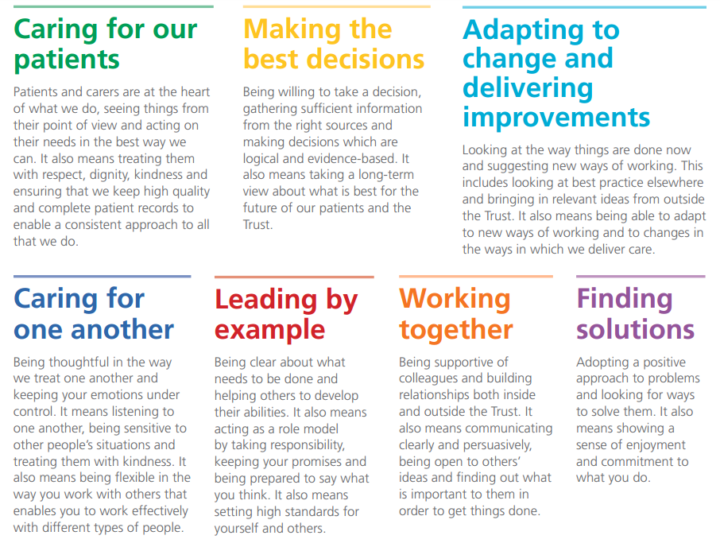

To make sure the Trust’s vision is realised, and our staff are successful in their roles, all of our people need to display each of our seven behaviours at the individual level.

|  |  |
| --- | --- |
| **Effort Factor Information** | |
| **PHYSICAL EFFORT**  What physical skills needed in the role require, speed, accuracy, dexterity and or manipulation of objects (includes both clinical and non-clinical posts)? Please provide specific examples.  Is the post holder required to lift equipment? If yes, please specify type of equipment, weight (approx kilos) and frequency of the requirement. Please provide specific examples. | Frequent sitting or standing in a restricted position e.g. crouching or kneeling to deliver care  Frequent moderate / occasional intense effort for several short periods  Treatment sessions may require the post holder to undertake moving and handling tasks with the patient which may or may not involve using specialist equipment  Occasional requirement to transport bulky equipment to patients’ homes if appropriate to service |
| **MENTAL EFFORT**  Describe the amount of concentration required within the day-to-day job. What is it the employee will have to concentrate on? Please give examples of how often and for how long this concentration occurs. Please provide specific examples of when mental effort is required.  Is the post holder required to drive a vehicle? If so please specify duration and frequency. | Frequent concentration required for the assessment and treatment of patients, work pattern predictable  If required for service delivery, short periods of driving on a regular basis to fulfil service needs. |
| **EMOTIONAL EFFORT**  Does any part of the job require any emotional effort? What elements of the role expose the employee to emotional effort?  How often does this happen? Please provide specific examples. E.g. exposure to child protection issues | Occasional distressing situations e.g. imparting unwelcome news to patients and carers, caring for terminally ill  Exposure to vulnerable groups |
| **WORKING CONDITIONS**  Is the post holder required to work in extreme heat or cold, with smells, noise or fumes which are unavoidable, even with the strictest health and safety controls? Does the post holder work with clients or patients who express aggressive verbal or non-verbal behaviour or similar. Please describe the requirement and the frequency with which this may occur. | Occasional exposure from patients and carers to verbal and / or physical aggression  Frequent exposure to unpleasant conditions e.g. body odours, fleas/lice, inclement weather  If required for service delivery, occasional exposure to highly unpleasant conditions e.g. body fluids |

**TERMS AND CONDITIONS OF SERVICE**

|  |  |
| --- | --- |
| **Band:** | 5 |
| **Hours:** | 30 |
| **Contract:** | Permanent |
| **Salary:** | £31,04 - £37,796 per annum pro rata |
|  | New staff will normally be appointed to the minimum of the pay band. Staff transferring from one post to another in the same pay band within the NHS will enter the band at the same point that they were previously on. Staff promoted within the NHS will enter the new pay band at the minimum or the first point of the new pay band that gives them an increase in salary. Any previous NHS service will be subject to confirmation by the Payroll Department. |
| **Annual Leave:** | The annual leave year runs from 1 April to 31 March following.  The full entitlement being 27 days for a full year and pro rata  for an incomplete year's service. An additional 2 days will be  awarded after 5 years service plus a further 4 days after 10  years service. This is in addition to 8 public and statutory days  holiday. |
| **NHS Pension:** | The post is pensionable unless you opt out of the scheme or  are ineligible to join and your remuneration will be subject to  deduction of contributions in accordance with the National  Health Service Pension Scheme. In the event of you not  wishing to join the scheme you should complete form SD502  on your commencement date. |
| **Medical:** | The appointment maybe subject to you completing a declaration of health form, which may lead to a full medical examination upon request. |
| **Notice:** | Giving notice – you are required to give the Trust 8  weeks written notice of termination of your employment.  Receiving notice – with the exception of ‘Summary Dismissal’ you will be entitled to receive notice of 8 weeks or your statutory notice entitlement whichever is the greater.    Statutory entitlement is:  For staff with more than 4 weeks continuous service, entitlement to notice is 1 week for each year of completed service up to a maximum of 12 weeks. |
| **PROFESSIONAL REGISTRATION**  Where it is a requirement as part of this job role to be registered with a Professional Body, you are required to maintain and update your registration in line with the Trust’s Professional Registration Policy. You are required to provide proof of your registration status on your appointment, at renewal of registration or at any other time as requested by the Trust. It is also a requirement for you to comply with any Codes of Professional Conduct and to update/satisfy any Continuous Professional Development conditions.  It would also be a requirement for you to comply with any Codes of Professional Conduct and to update/satisfy any Continuous Professional Development conditions.  **REHABILITATION OF OFFENDERS ACT 1974**  Because of the nature of the work for which you are applying, this post is exempt from the provisions of Section 4(2) of the Rehabilitation of Offenders Act 1974. Applicants are, therefore, not entitled to withhold information about convictions which for other purposes are 'spent' under the provisions of the Act, and, in the event of employment any failure to disclose such convictions could result in dismissal or disciplinary action by the Trust. Any information given will be completely confidential and will be considered only in relation to an application for positions to which the Order applies.  **DBS CHECK (Formerly CRB)**  This post is subject to the Rehabilitation of Offenders Act (Exceptions Order) 1975 and as such it will be necessary for a submission for Disclosure to be made to the Disclosure & Barring Service to check for any previous criminal convictions.  The Trust is compliant with the Disclosure & Barring Service ‘Code of Practice’, a copy of which is available on request.  The Trust welcomes applications from a wide range of candidates including those with a criminal record. It undertakes not to discriminate unfairly against any subject of a Disclosure on the basis of a conviction or other information revealed. A full Trust policy on the Recruitment of Ex-offenders is available on request.  **SECTION 11 COMPLIANCE**  **Safeguarding Children and Vulnerable Adults**  All employees are required to act in such a way that at all times safeguards the health and well being of children and vulnerable adults. Familiarisation with and the adherence to the Trust’s Safeguarding policies is an essential requirement of all employees as is participation in related mandatory/statutory training.  **ORGANISATIONAL AND STATUTORY REQUIREMENTS**  All employees should understand that it is their personal responsibility to comply with all organisational and statutory requirements, e.g. Health and Safety; Equal Treatment and Diversity; Confidentiality; Infection Prevention and Control.  **MENTAL CAPACITY ACT (MCA 2005 CODE OF PRACTICE)**  This Act applies to all persons over the age of 16 who are judged to lack capacity to consent or withhold consent to acts which are considered by health and social care professionals to be in the best interests of their welfare and health.  The Mental Capacity Act 2005 imposes a legal requirement on health and social care professionals to ‘have regard to’ relevant guidance within the Code of Practice when acting or making decisions on behalf of someone who lacks capacity to make the decision for themselves. Furthermore, they should be able to explain how they had regard to the Code when acting or making decisions.  Detailed guidance is available in the Mental Capacity Act 2005 Code of Practice http://www.dca.gov.uk/legal-policy/mental-capacity/mca-cp.pdf  **NOTE**  This job description does form a part of the contract of employment and indicates how that contract should be performed. The job description will be subject to amendment in the light of experience and in consultation with the postholder.  **JOB SHARE**  This post is suitable for job sharing and when filled on this basis will attract all normal terms and conditions of service outlined above, but on a pro rata basis if appropriate.  **SMOKING**  The Trust operates a no smoking policy and is smoke free. | |

LEEDS COMMUNITY HEALTHCARE NHS TRUST

PERSON SPECIFICATION – Community Staff Nurse

|  |  |  |  |
| --- | --- | --- | --- |
| **Attributes** | **Essential** | **Desirable** | **How identified?** |
| **QUALIFICATIONS** | Professional degree or diploma in relevant field  Current NMC registration | Mentorship qualification | Application |
| **EXPERIENCE** | Working as part of a multidisciplinary team | Working in community or primary care based teams  Experience of facilitating clinical supervision | Application |
| **KNOWLEDGE & UNDERSTANDING** | Theoretical and clinical knowledge appropriate to service area  Current issues in healthcare  Standards of Conduct  Is aware of confidentiality in relation to role |  | Application  Interview |
| **PRACTICAL & INTELLECTUAL SKILLS** | Demonstrates effective written communication and verbal communication  Assessment, planning and evaluation skills  Proficiently performs tasks relevant to clinical role  Manage workload and delegate tasks  Risk assessment skills  Reflective practice skills  Ability to research, understand and evaluate evidence to contribute to practice development | Has competent IT skills or is willing to under training  Demonstrates ability to teach & assess outcome for patients/carers & students | Application  Interview  Test |
| **TRAINING** | Must be willing to participate in any relevant training identified to develop skills required to carry out duties |  | Application Form  Interview  References |
| **ATTITUDE & BEHAVIOUR** | Displays care, compassion and responsiveness to other peoples’ feelings and needs  Able to work as part of a team and assist wherever possible  Able to develop, establish and maintain positive relationships with others both internal and external to the organisation  Able to work under pressure, dealing with peaks and troughs in workload  Positive attitude to dealing with change  Able to respond to changing needs of patient of in an appropriate and timely manner  Willing to change and accept change and to explore new ways of doing things and approaches  Highly motivated and reliable  Demonstrates values consistent with those of the Trust  Has a strong degree of personal integrity; able to adhere to standards of conduct based on a sense of right and wrong and be dependable and reliable |  | Application Form  Interview  References |
| **Please delete as applicable:** Car owner/driver or suitable alternative transport to enable you to undertake the job (it is unlikely that public transport will meet this requirement). Reasonable adjustments can be considered in accordance to the Equality Act. | | | |