

LEEDS COMMUNITY HEALTHCARE NHS TRUST

JOB DESCRIPTION

Job Details
Job Title:  Banding:  Hours:  Specialty/Department:  Reports to:  Accountable for: | Clinical research fellow  Clinical Band 7  0.71-0.81WTE depending on point of band 7  Please note this post is fixed term until 2.11.27.  Long Covid Rehabilitation Service  Chief Investigator and Principal Investigator HERITAGE research project  Supporting the delivery of the HERITAGE programme of work

Service Description

Persistent Long covid (LC) or post-COVID syndrome, defined as LC present for > 2 years and Myalgic Encephalomyelitis/Chronic Fatigue Syndrome (ME/CFS) are long-term conditions that together affect > 1.5 million people in the UK alone and > 60 million worldwide. Both conditions have significant overlapping symptoms, are linked to infections, and have some common underlying pathophysiology. The burden to the UK economy per year is estimated to be £8.1 billion for LC and £3.3 billion for ME/CFS. There is an urgent need for health services research and developing a National Service Framework that will improve care in existing services and effectively reduce the overall costs to the NHS and the UK economy. The £1.4 million NIHR HERITAGE project (Health Effects fRom Infection sequelae: Tailoring services and Advancing GuidancE) project aims to address these needs.

The post holder will support the HERITAGE NIHR grant activities; i.e. supporting all activities related to the use of mixed-method research and engagement of front-line clinicians and patients, to improve care of LC: a) in specialist clinics, b) by patients at home and c) in primary care. The work comprises of three work streams plus PPI/E:
o WORK STREAM I: Exploring the diagnostic overlap between LC and ME/CFS, condition trajectories and long-term clinical outcomes in both conditions
o WORK STREAM II: Evaluating the cost-effectiveness of alternative service models for LC and ME/CFS
o WORK STREAM III: Improving quality of care for LC and developing a national service framework for LC and ME/CFS
o PPI/E: Individuals with lived experience of LC and ME/CFS have contributed to proposal design and will remain actively involved in all aspects of study through on-going co-creation.
Job Purpose

The post holder will contribute to this activity under the leadership of the Chief Investigator and Principal Investigator. Working effectively with the immediate and broader multidisciplinary teams and the multi-centre research teams, being responsible for ensuring that high standards of clinical research, research planning, delivery, safety and patient satisfaction is to a very high standard, compliant with Trust policy, study protocol requirements, local and national guidance and legislation.
The post holder will be responsible for the coordination of and the development of their own training needs in respect of this post.
The post holder will working effectively and proactively with agreed external agencies and collaborative partners such as research teams across University sites and clinicians within LC Community Rehabilitation Services, the individual will adhere to agreed activities and processes (see fig) workstream and tasks of the project) to derive accurate and robust data capture.
Fig) HERITAGE flow diagram
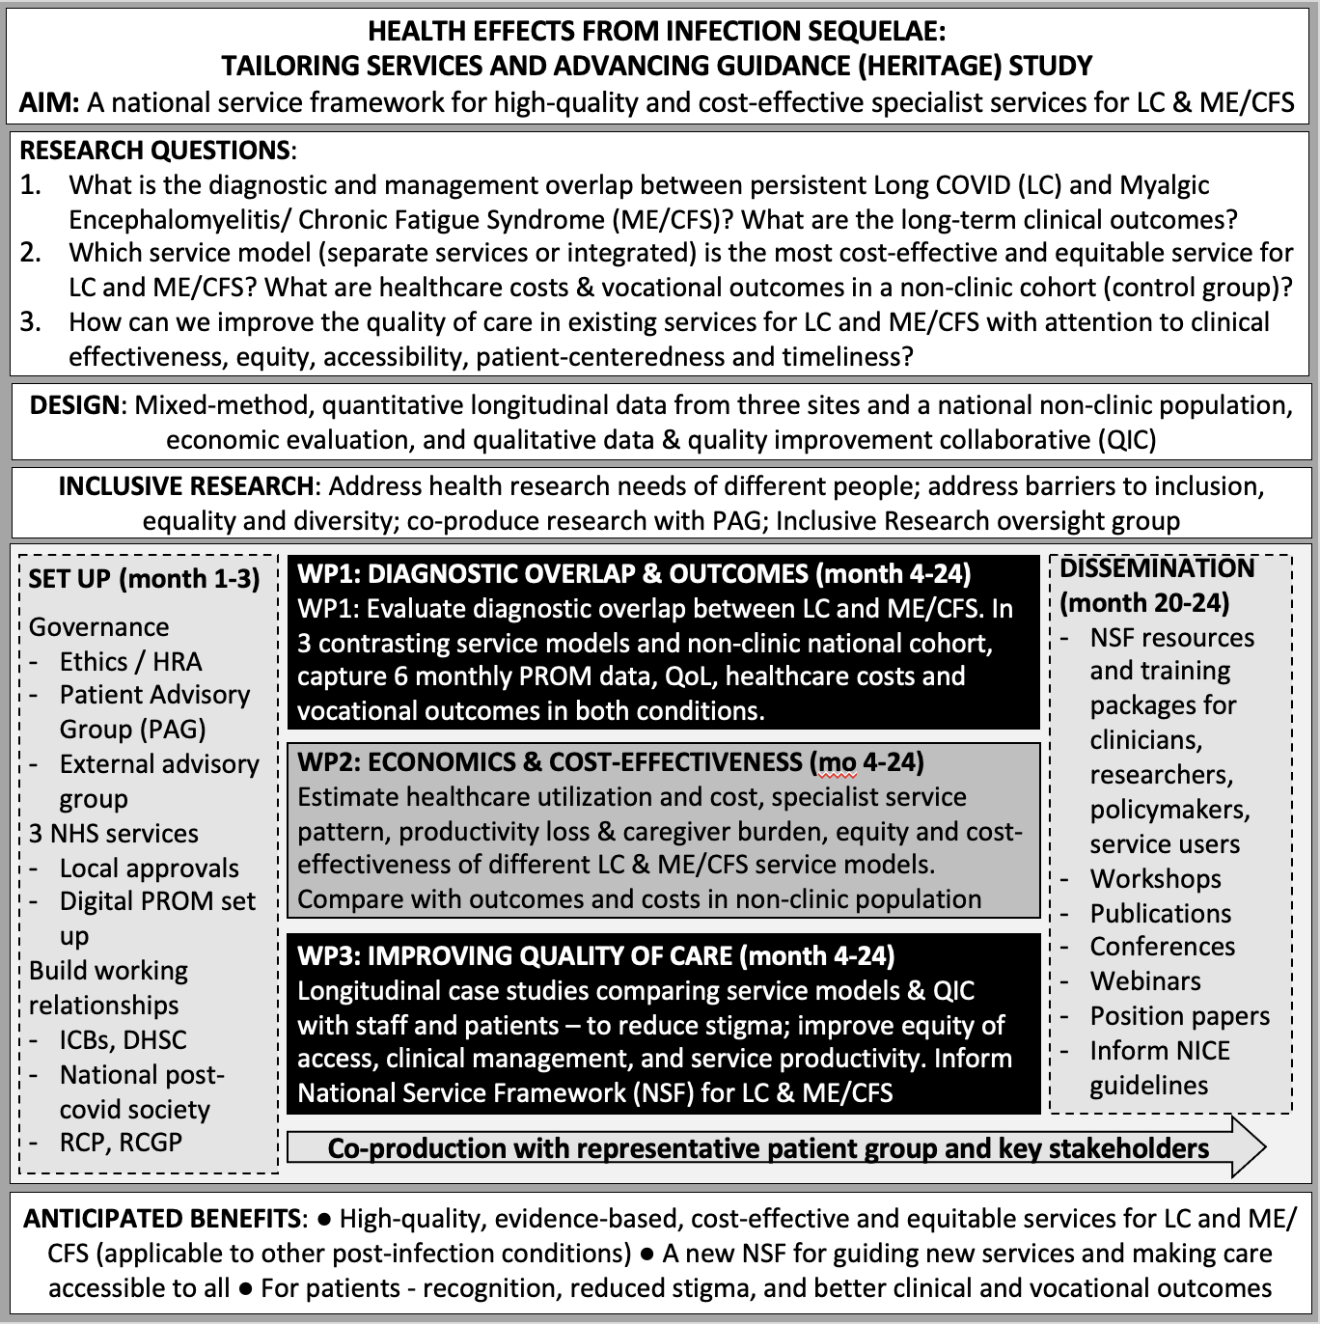
The post holder will act as a role model developing the research team and ensuring effective management of the project in the absence of the Chief Investigator or Principal Investigator. During exceptional times of need, you will contribute to clinical service, as agreed with the Head of Profession for the CSU and in line with the Trust’s escalation policy.
The post holder will be involved in ensuring that research undertaken within the department safeguards the wellbeing of patients and is conducted within the confines of ICH Good Clinical Practice Guidelines for Research, EU directive, UK Governance Framework and other relevant UK legislation pertaining to the conduct and delivery of research.
We are looking to recruit a proactive and self-motivated, individual with a keen interest in research, to work within HERITAGE Team. The post will support activities across the patient pathway and clinical settings. You should be able to adopt a flexible approach to engaging with multiple team members and representing the HERITAGE research team in both internal and national meetings. You must have effective organisational skills and be looking for a new and exciting challenge. You should demonstrate the ability to manage your own work load and direct the work of others to ensure the team succeeds.
The post holder will be required to work alongside academic and industry partners, the National Institute for Health Research (NIHR) Clinical Research Network (CRN) Yorkshire and Humber (Y&H) and colleagues in neighbouring establishments, attending regional and national meetings as required.
The post holder is required to maintain up to date GCP certification. We will support the post holder to develop and complete the associated PI course whilst in this role.

Key Responsibilities

1. Clinical/research
- Utilises highly developed specialised knowledge covering a range of procedures and underpinned by relevant broad based knowledge, experience and competence
- Where appropriate to service delivery, demonstrates highly developed physical skills requiring accuracy and dexterity e.g. moving and handling techniques, clinical procedures, diagnostic tests
- Demonstrates independent practice responding to social, scientific, clinical and ethical issues which are encountered
- Makes complex judgements requiring analysis, interpretation and comparison of options by integrating complex knowledge sources in new and/or unfamiliar contexts
- Responsible for clinical pathways appropriate to field of work
- Engages and actively involves the individual and, if appropriate, their family/carer, in the assessment, planning, implementation and evaluation of programmes of treatment/research and/or care by using person-centred techniques to promote a culture of self care and empowerment
- Works to standards of proficiency identified by their professional and regulatory bodies performing clinical treatments/procedures/research to a highly specialist standard
- Prioritises their own workload and that of the wider team within agreed objectives deciding when to refer to others as appropriate.
- Provides and receives complex, sensitive or contentious information where motivational, persuasive, empathetic, negotiating and reassurance skills are required whilst demonstrating an understanding of barriers to communication
- Approaches each individual with care, compassion and sensitivity ensuring that these values are reflected in all aspects of role including the management of complaints and compliments.
- To comply with the organisations’ Infection Prevention and Control requirements, including “bare below the elbows” dress code for staff with a direct care delivery role

2. Leadership
- Ensures that a professional service and image is maintained at all time, thereby acting as a role model to all staff
- Provides a leadership style which is underpinned by strongly held values around equality, diversity and openness; effectively builds and maintains relationships with direct reportee(s), management team and other key individuals both across the organisation and nationally.
- Ensures the effective and efficient use of resources e.g. staff, supplies within their own sphere of responsibility.
- Demonstrates leadership and innovation in contexts which are unfamiliar, complex, and unpredictable that require solving problems involving many interacting factors
- Demonstrates the ability to delegate, organise and prioritise workload to ensure the safe delivery of the service including the management of referrals and discharges utilising locally agreed support mechanisms e.g. on call manager and making judgements in complex situations
- Demonstrates resilience when responding to challenge, change and complex or difficult situations
- Demonstrates research leadership, initiative and creativity in developing projects inspiring others to be positive in their contribution to continuous improvement
- Clearly articulates the expected clinical research standards of the service, monitors and identifies where standards are not met and takes action to address
- Ensures that all objectives, for self and those directly responsible for, are clearly defined within the wider Directorate framework and in line with Trust’s objectives, using the appraisal process as a vehicle for this.
- Takes responsibility for their own and others’ health and safety in the working environment.

3. Learning and Development
- Undertakes any training required to develop and maintain their proficiency in response to changes in service delivery or new and emerging techniques and demonstrate competence within professional body requirements
- Reflects on and evaluates own practice and identifies areas of development by setting appropriate objectives via appraisal and clinical/academic supervision
- Initiates and develops research and development programmes appropriate to clinical practice
- Devises and delivers specialist training and development programmes within team and to other services, teams or agencies
- Provides high quality, specialist advice related to clinical specialism to other practitioners, agencies and individuals
- Ensures appraisals for direct reportees are undertaken in accordance with Trust policy; manages performance which falls below standard in accordance with the appropriate HR policies and processes seeking support from senior staff where required
- Supports the learning and development of others including students and preceptees

4. Partnership and Team Working

Actively develops and maintains effective clinical research and corporate working relationships both within and outside the Trust including with other agencies and Higher Education Institutes
- Explores the potential for collaborative working and takes opportunities to initiate and sustain such relationships in order to improve research delivery
- Actively contributes to the multi-disciplinary team supporting the patient; acting as a credible source of information for other agencies/professionals involved in the care; act as a resource of highly specialist knowledge for others

5. Innovation and Quality
- Works with managers and colleagues to continually improve the quality of service and research delivery within the overall organisational governance frameworks and corporate objectives reflecting the changing needs of the population, local and national initiatives e.g. suggesting changes to pathways or processes
- Implements, monitors and maintains agreed standards, reporting to the team/service manager when standards are not met
- Implements policies relevant to service area and ensures team members are aware of policy requirements
- Initiates and leads clinical audit and ensures relevant action plans are completed.
- Identifies, manages and minimises risks within the overall organisational risk management frameworks supporting other staff to contribute to the process. This includes understanding and applying knowledge of clinical role in safeguarding and incident management
- Acts as an advocate for patients and their families/carers recognising the boundaries of their clinical and research knowledge; liaising and referring on to other services / agencies as required
- Ensures that patient experience is core to all research, clinical and service development gaining support from the appropriate corporate teams as required
- Develops and implements innovative practice to contribute to the Quality Framework, outcome measures and best practice standards in order to deliver an effective, high quality service

Health and Safety

Responsibilities of ALL staff in relation to Health and Safety:-
- Take reasonable care of your own health and safety
- Take reasonable care not to put other people - fellow employees and members of the public - at risk by what you do or don't do in the course of your work
- Co-operate with Trust, making sure you understand and follow the health and safety policies and procedures
- Attend all required training on Health and Safety related policies and procedure.
- Do not interfere with or misuse anything that has been provided for your health, safety or welfare
- Report and record any injuries, strains or illnesses suffered as a result of doing your job
- Inform your manager if something happens that might affect your ability to work safely such as suffering an injury or a new medical condition.

Additional for those with management responsibilities:
- Identify through documented risk assessment any risks that exists within the department or during the delivery of the service
- Investigate and manage incidents and near misses, ensuring actions are taken to prevent recurrence
- Support the Risk and Safety Team in ensuring suitable and sufficient up to date Health and Safety information and guidance is available to all staff at all levels and disciplines across the organisation.

In addition to these functions the post holder is expected to:
- In agreement with their line manager carries out such other duties as may be reasonably expected in accordance with the grade of the post.

Effort Factor Information
PHYSICAL EFFORT  What physical skills needed in the role require, speed, accuracy, dexterity and or manipulation of objects (includes both clinical and non-clinical posts)? Please provide specific examples.  Is the post holder required to lift equipment? If yes, please specify type of equipment, weight (approx kilos) and frequency of the requirement. Please provide specific examples. | Frequent sitting, standing, restrictive position; moderate effort for several short periods.  Sitting / kneeling in restricted positions whilst delivering therapy or treatment
MENTAL EFFORT  Describe the amount of concentration required within the day-to-day job. What is it the employee will have to concentrate on? Please give examples of how often and for how long this concentration occurs. Please provide specific examples of when mental effort is required.  Is the post holder required to drive a vehicle? If so please specify duration and frequency. | Frequent concentration required e.g. during patient interaction, compilation of reports, data analysis. A need to manage interruptions to deal with urgent issues
EMOTIONAL EFFORT  Does any part of the job require any emotional effort? What elements of the role expose the employee to emotional effort?  How often does this happen? Please provide specific examples. E.g. exposure to child protection issues | Frequent distressing or occasional highly distressing or emotional circumstances e.g. deals with distressed patients or relatives, imparting distressing news in relation to clinical status (e.g. complex or degenerative conditions), managing staff; dealing with safeguarding concerns; challenging behaviour
WORKING CONDITIONS  Is the post holder required to work in extreme heat or cold, with smells, noise or fumes which are unavoidable, even with the strictest health and safety controls? Does the post holder work with clients or patients who express aggressive verbal or non-verbal behaviour or similar. Please describe the requirement and the frequency with which this may occur. | Frequent unpleasant; occasional highly unpleasant conditions – environment, smells, lice/fleas, verbal aggression, body fluids

LEEDS COMMUNITY HEALTHCARE NHS TRUST
PERSON SPECIFICATION – Clinical Band 7

Attributes | Essential | Desirable | Method of Assessment
QUALIFICATIONS  & TRAINING | Professional degree or diploma in relevant field  If required, qualification specific to specialist field  Post graduate learning to Masters level or equivalent  Appropriate statutory professional body registration  Must be willing to participate in any relevant training identified to develop skills required to carry out duties  Maintains a portfolio of CPD in line with regulatory body standards  Teaching, training or mentorship qualification or experience to an equivalent level  Certificate in Good Clinical Practice (or working towards) | Specific CPD modules relevant to specialist field  Leadership and management qualification  Research courses or modules at MSc level or above  NIHR or equivalent principle investigator training course. | Application  Interview  References
EXPERIENCE | Experience in the specialist clinical research field  Experience in the supervision and management of other staff  Experience in the teaching and training of others in a variety of settings e.g. clinical, academic | Working in community or primary care based teams  Experience of leadership in practice  Experience of leading clinical audit and leading changes in pathways and processes.  Experience of leading pathways  Experience of supporting staff including relevant processes and policies  Experience of working with a research group regionally or nationally | Application  Interview
KNOWLEDGE & UNDERSTANDING | Highly developed specialist theoretical and clinical knowledge appropriate to service area and profession  Highly developed knowledge of professional standards and application in practice  Highly developed knowledge of relevant current issues in health and social care, ethics and innovation and application in practice  Demonstrates awareness of limits to knowledge base  Experience of leading the application of clinical governance and quality measures in practice  Knowledge of specific innovation techniques / initiatives e.g. Productive Community / Ward Series (Leeds Approach)  Knowledge of current research methodology | Experience of practical application of innovation techniques  Evidence of research projects and/or clinical audit relevant to clinical area  Understanding and track record in research delivery  Knowledge of the legal framework for research | Interview
PRACTICAL & INTELLECTUAL SKILLS | Highly specialist assessment, planning, treatment and evaluation skills appropriate to clinical area  Performs highly specialised tests / procedures / diagnostics relevant to clinical role to an advanced level  Highly complex analytical and creative problem solving skills in unpredictable situations  Workload management including delegation of tasks and day-to-day team leadership  Competent IT skills in order to collect and interpret data, present reports and compile presentations in a range of contexts  Advanced verbal, non-verbal and written communication skills including communicating complex or potentially distressing information to patients / carers and managing conflict when appropriate  Risk assessment skills  Reflective practice skills – able to give clear and effective feedback and support others to develop  Develop and lead clinical audit within clinical area  Lead / contribute to research activities relevant to clinical area | Experience in research skills such as ethics applications and/or clinical audit | Application  Interview  Test
ATTITUDE & BEHAVIOUR | Able to demonstrate clear and inspiring clinical leadership internally and externally behaving as a role model at all times  Displays care, compassion, sensitivity and responsiveness to other peoples’ feelings and needs  Able to work as part of a team, co-operating to work together and in conjunction with others and willing to help and assist wherever possible and appropriate appreciating the value of diversity in the workplace  Able to develop, establish and maintain positive relationships with others both internal and external to the organisation and with patients and their carers  Able to work under pressure, dealing with peaks and troughs in workload managing unpredictable service demands  Positive and flexible attitude to dealing with change; able to respond to the changing needs of the patient in an appropriate and timely manner;  willing to change and accept change and to explore new ways of doing things and approaches  Highly motivated and reliable  Has a strong degree of personal integrity; able to adhere to standards of conduct based on a culture of equality and fairness  Demonstrates values consistent with those of the Trust | Evidence of clinical leadership  Experience of change management theory | Application Form  Interview  References  Test
Please delete as applicable: Car owner/driver or suitable alternative transport to enable you to undertake the job (it is unlikely that public transport will meet this requirement). Reasonable adjustments can be considered in accordance to the Equality Act.

